14.Create a Virtual Hard Disk and allocate the storage using VM ware Workstation

Step 1:Having already hard disk and next allocating new hard disk

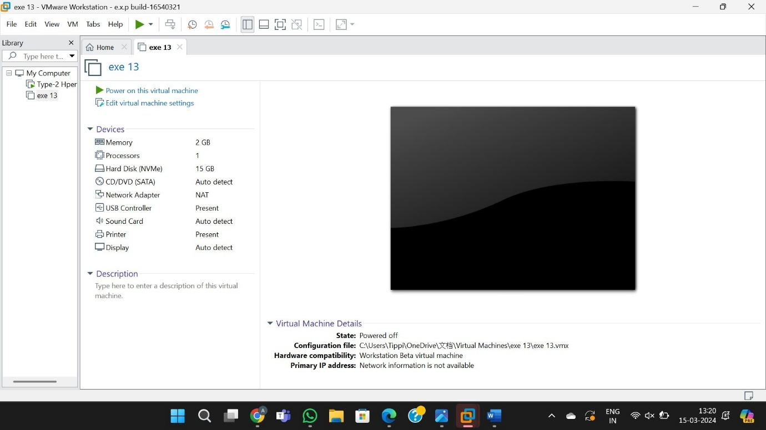

Step 2:Allocated new harddisk for the experiment

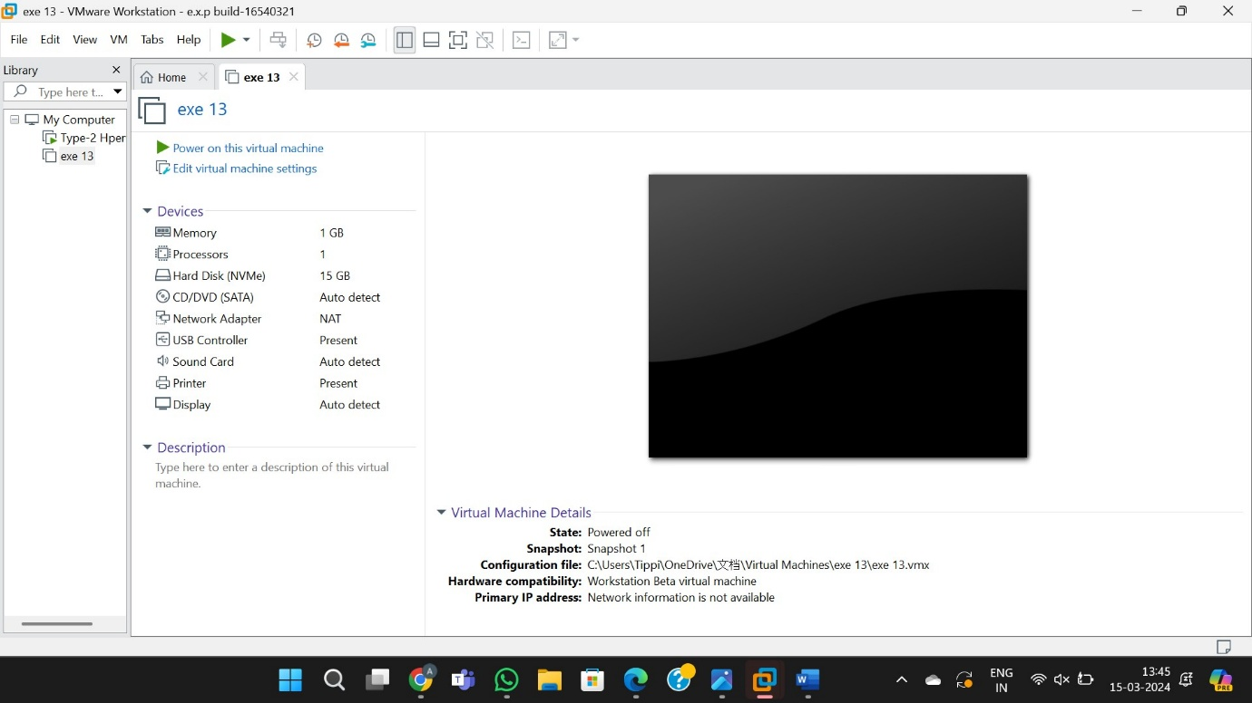

Step 3:Taking back to snapshot 1

